Temasek Polytechnic
School of Informatics and IT

Diploma in Information Technology (IT)

Software Test Specifications (STS)

Project Particulars

Tutor | Goh Mya Hu, Mel
Class | P01
Project Title | Delonix Regia Hotel Management System

Project Team’s Particulars

Matric Number | Student Name
1506070J | Lexus George
1503103B | Ryan Ng Zi Feng
1501169E | Yip Cherng Yorng
1502712A | Leng Yin Long

Revision History

Date | Version | Description | Author
05/06/2017 | 1.0 | Added Distribution of workload, Module development and unit testing, test log | Lexus
06/06/2017 | 1.1 | Added pictures for Housekeeping, Booking, Test plans | Lexus

Table of Contents

1. DISTRIBUTION OF WORKLOAD 4
2. MODULE DEVELOPMENT AND UNIT TESTING 4
2.1 Staff Management 4
2.2 Booking 6
2.3 Housekeeping 8
2.4 Room Availability 10
3 SYSTEM INTEGATION 11
4 TEST LOG 12
4.1 Ryan Ng Zi Feng 12
4.1.1 Add Booking 12
4.1.2 Find Booking 12
4.1.3 Edit Booking details 13
4.1.4 Delete Booking details 13
4.2 Lexus George 14
4.2.1 Add Staff 14
4.2.2 Find Staff 14
4.2.3 Edit Staff 15
4.2.4 Delete Staff Record 15
4.3 Yip Cherng Yorng 16
4.3.1 Add Housekeeping role 16
4.3.2 Find Housekeeping 16
4.3.3 Edit Housekeeping 16
4.3.4 Delete Housekeeping record 17
4.4 Leng Yin Long 18
4.4.1 Add Room details 18
4.4.2 Find Room details 18
4.4.3 Edit Room details 18
4.4.4 Delete Room details 19
4.4.5 Find Occupied room 19

DISTRIBUTION OF WORKLOAD

Construction & Testing | Members
Staff Management | Lexus George
Booking | Ryan Ng Zi Feng
Housekeeping | Yip Cherng Yorng
Room Availability | Leng Yin Long

MODULE DEVELOPMENT AND UNIT TESTING

Staff Management
For the staff management module, we should create database of the staff. It will then link to other tables – which are housekeeping, booking and payment. The staff form will record the required details.

When creating a new staff, the admin must enter the necessary details staffID, username, password, Fname, Lname, Contact, Address, IDNo, Email, position, housekeepingID, notes. Then the admin will add the details. For the testing of CRUD, dummy data will be added using add new staff function.

To check whether if data is shown in the database, I use the find staff function to check for respective data I want. After searching, I can change the values and save the data, or even delete the record if the staff is no longer working in the hotel

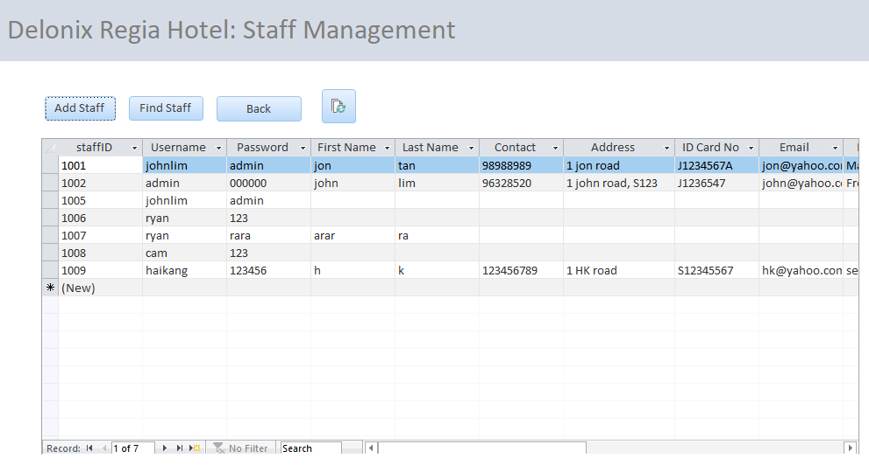
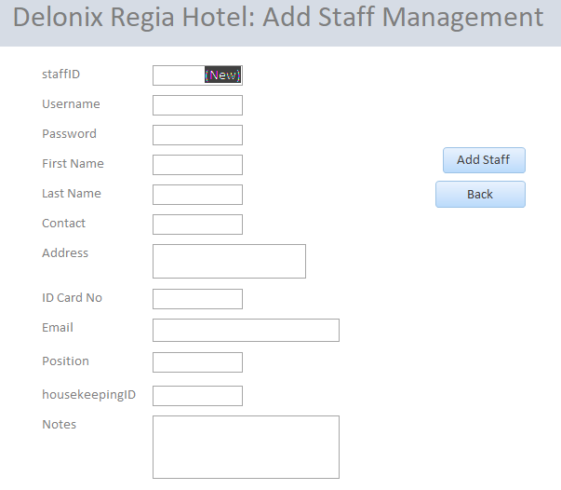
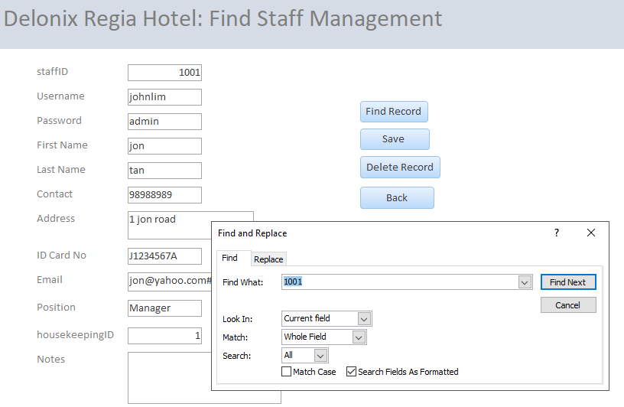

Booking
To create the booking module, we first have to create the tables required which is the booking table and room table. Then we link the two tables together using room number as the foreign key. The booking form will be created after linking the tables, the form will have the CRUD functions where the staff/admin can create a new booking, find existing booking via Booking ID/Room Number, update existing booking and delete existing booking.

When creating a new booking, the staff/admin will be required to enter their ID and the customer details – name, address, payment detail and the room detail. Both the staff and admin can view and generate report for the booking module. For the testing of the CRUD function, dummy data was added using the add booking function.

To check if the dummy data was added in the database, I use the find booking function to search for the dummy data in the database. After finding the dummy data, I then change the value and updated the dummy data. Next, I test the delete function by deleting the dummy data.
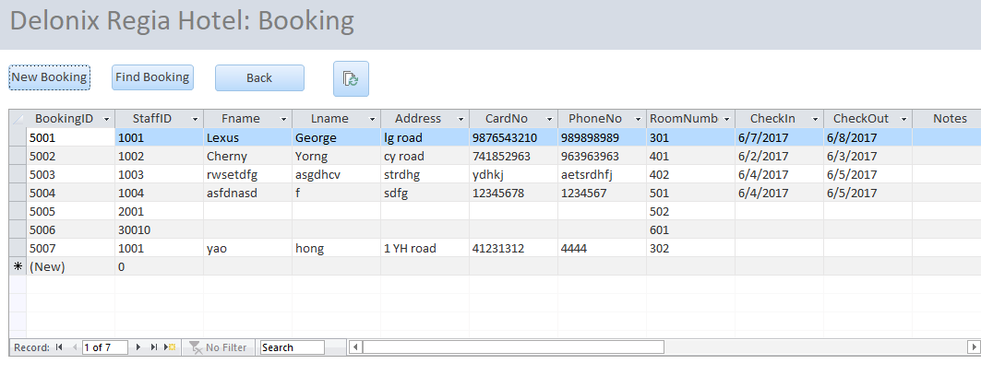

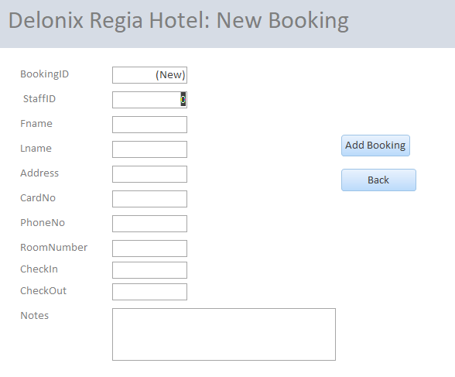
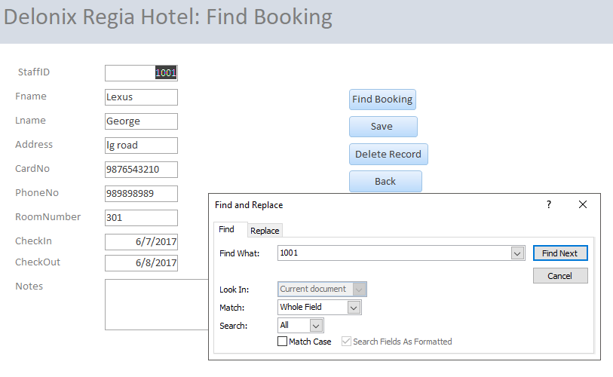

Housekeeping
To create the housekeeping module, I have to create the housekeeping database table first. The attribute used in the table are housekeepingID, staffID, RoomNumber, Roles, Date, Time and Notes. After creating the housekeeping table, it will be link with other table in the staff management table and room availability table using staffID and RoomNumber as the foreign key respectively.

Then I will create a page for the housekeeping CRUD function to work. In that page, it shows the current table of housekeeping module. There will also be 4 button in that page, new housekeeping, find housekeeping, back and refresh.
When click on the new housekeeping button, it will direct to another page with empty field form for the staff/admin to enter the details of the new housekeeping. For testing the create function for the housekeeping module, a few dummy data was added using this new housekeeping function.

The find housekeeping button is use to do the RUD function. After click that button, it will proceed to another page where a message will pop up for the user to retrieve a housekeeping data. After finding the specific housekeeping data, the field will display the specific housekeeping data where the staff/admin are able to update or delete it. To check if the dummy data was added into the database, I will use the find housekeeping function to search for the dummy data in the database. Then I will change the value and updated the dummy data. After confirming that the function works, next, I will then test the delete function by deleting the dummy data.
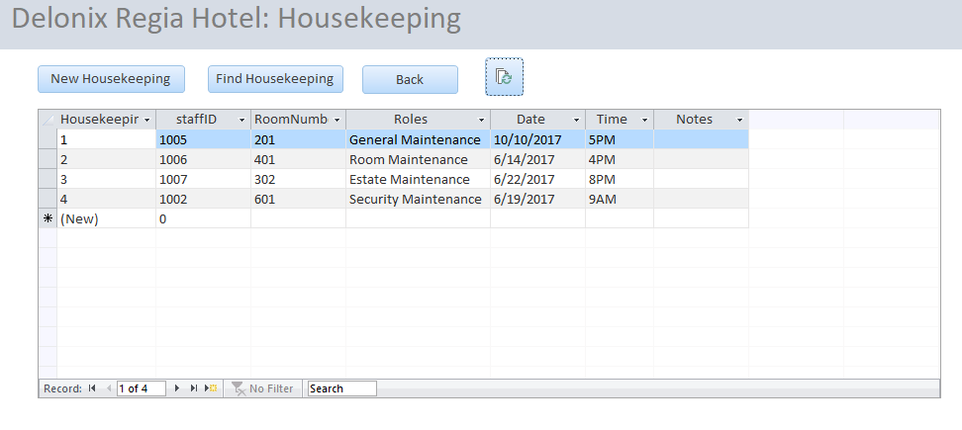

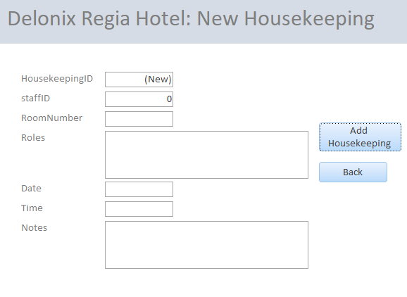
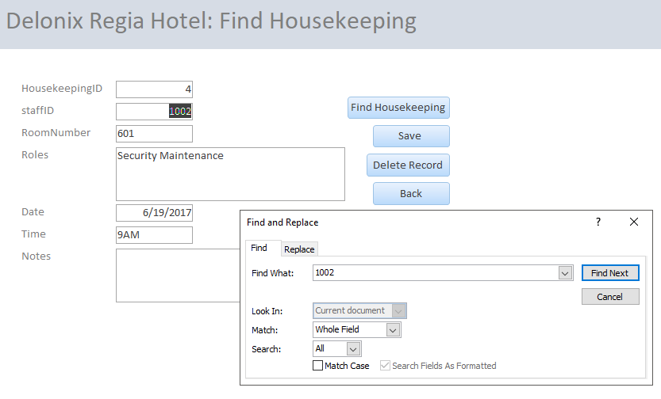

Room Availability

SYSTEM INTEGATION
[Describe how system integration is done. How do you ensure that your software modules from different team members can be integrated during the integration phase? What strategies have you used?]

TEST LOG

Ryan Ng Zi Feng

Add Booking

S/No | Steps | Test Data | Expected Results | Actual Results | Remarks
1 | Click ‘Booking’
2 | Click ‘New Booking’
3 | Add details | Staff ID: 1001  Fname: Kim  Lname:  Lim  Address: KL Road  Card no:  98765321  Phone no:  98989898  Room Number:  401 | New booking added | New booking added
4 | Click Back |  | Go back to Booking page | Go back to Booking page

Find Booking
S/No | Steps | Test Data | Expected Results | Actual Results | Remarks
1 | Click ‘Booking’
2 | Click ‘Find Booking’
3
4 | Click Back |  | Go back to Booking page | Go back to Booking page | Nil

Edit Booking details
S/No | Steps | Test Data | Expected Results | Actual Results | Remarks
1 | Click ‘Booking’
2 | Click ‘Find Booking’
3
4 | Click Back |  | Go back to Booking page | Go back to Booking page | Nil

Delete Booking details
S/No | Steps | Test Data | Expected Results | Actual Results | Remarks
1 | Click ‘Booking’
2 | Click ‘Find Booking’
3
4 | Click Back |  | Go back to Booking page | Go back to Booking page | Nil

Lexus George
S/No | Steps | Test Data | Expected Results | Actual Results | Remarks
1 | Click Staff Details |  | Go to Staff page | Go to Staff page | -
2 | Click Add Staff |  | Go to Add Staff page | Go to Add Staff Page | -
3 | Add Staff details in the boxes provided | Staff ID: 1010  Username: Yin  Password: 111111  First Name: Yin  Last Name: Long  Contact: 98765432  Address: 1 YL road  ID Card No: S1122334U  Email: yl@yahoo.com.sg  Position: buyer  housekeepingID: NIL  Notes: NIL | New staff added | New staff added | New staff record added into the database
4 | Click Back |  | Go back to Staff page | Go back to Staff page | Nil

Add Staff
S/No | Steps | Test Data | Expected Results | Actual Results | Remarks
1 | Click Staff Details |  | Go to Staff page | Go to Staff page | -
2 | Click Find Staff |  | Go to Find Staff page | Go to Find Staff Page | -
3 | Search and finds a staff record | Find staff ID record of 1001 | Displays all the information of selected staff | Displays all the information of selected staff
4 | Click Back |  | Go back to Staff page | Go back to Staff page | Nil

Find Staff

Edit Staff

S/No | Steps | Test Data | Expected Results | Actual Results | Remarks
1 | Click Staff Details |  | Go to Staff page | Go to Staff page | -
2 | Click Find Staff |  | Go to Find Staff page | Go to Find Staff Page | -
3 | Search and finds a staff record | Find staff ID record of 1001 | Displays information of selected staff | Displays information of selected staff
4 | Edit the selected record | Change staff ID password from 1234 to 0000
5 | Click Save the record | Change staff ID password from 1234 to 0000 | Record is saved successfully | Record is saved successfully | New password changed
6 | Click Back |  | Go back to Staff page | Go back to Staff page | Nil

Delete Staff Record

S/No | Steps | Test Data | Expected Results | Actual Results | Remarks
1 | Click Staff Details |  | Go to Staff page | Go to Staff page | -
2 | Click Find Staff |  | Go to Find Staff page | Go to Find Staff Page | -
3 | Search and finds a staff record | Find staff ID record of 1005 | Displays information of selected staff | Displays information of selected staff
5 | Click Delete the record | Select staff ID 1005 record | Record is deleted successfully | Record is deleted successfully | Staff record deleted
6 | Click Back |  | Go back to Staff page | Go back to Staff page | Nil

Yip Cherng Yorng

Add Housekeeping role
S/No | Steps | Test Data | Expected Results | Actual Results | Remarks
1
2
3
4 | Click Back |  | Go back to housekeeping page | Go back to housekeeping page | Nil

Find Housekeeping
S/No | Steps | Test Data | Expected Results | Actual Results | Remarks
1
2
3
4 | Click Back |  | Go back to housekeeping page | Go back to housekeeping page | Nil

Edit Housekeeping
S/No | Steps | Test Data | Expected Results | Actual Results | Remarks
1
2
3
4 | Click Back |  | Go back to housekeeping page | Go back to housekeeping page | Nil

Delete Housekeeping record
S/No | Steps | Test Data | Expected Results | Actual Results | Remarks
1
2
3
4 | Click Back |  | Go back to housekeeping page | Go back to housekeeping page | Nil

Leng Yin Long

Add Room details
S/No | Steps | Test Data | Expected Results | Actual Results | Remarks
1
2
3
4 | Click Back |  | Go back to Room details | Go back to Room details | Nil

Find Room details
S/No | Steps | Test Data | Expected Results | Actual Results | Remarks
1
2
3
4 | Click Back |  | Go back to Room details | Go back to Room details | Nil

Edit Room details
S/No | Steps | Test Data | Expected Results | Actual Results | Remarks
1
2
3
4 | Click Back |  | Go back to Room details | Go back to Room details | Nil

Delete Room details
S/No | Steps | Test Data | Expected Results | Actual Results | Remarks
1
2
3
4 | Click Back |  | Go back to Room details | Go back to Room details | Nil

Find Occupied room
S/No | Steps | Test Data | Expected Results | Actual Results | Remarks
1
2
3
4 | Click Back |  | Go back to Room details | Go back to Room details | Nil

